Rule #62 by Candlelight
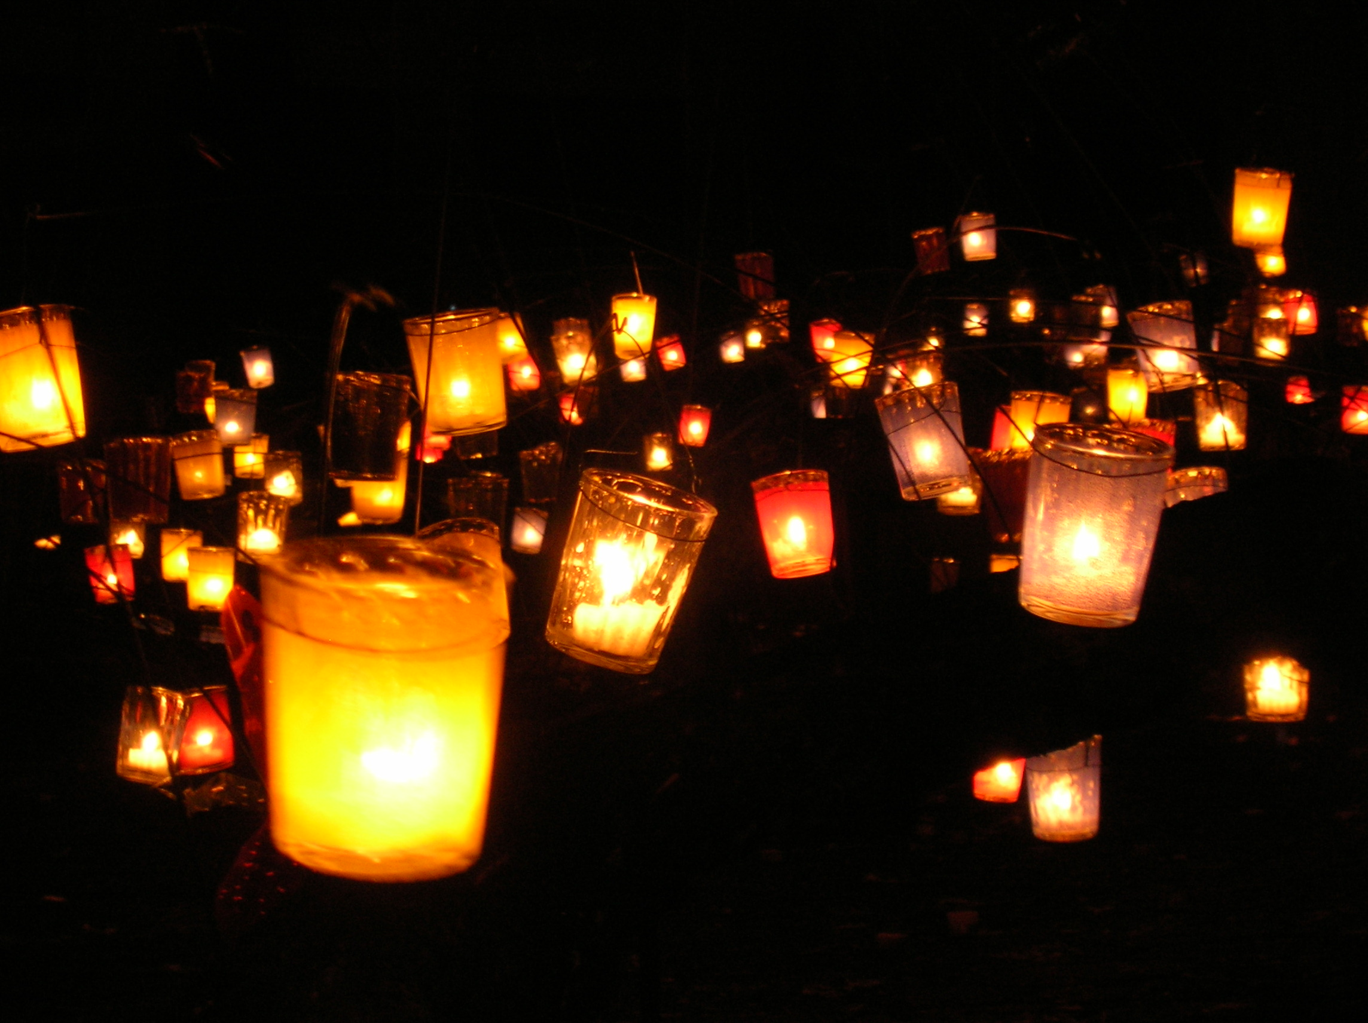
New Meeting Sponsored by Jacksonburg Home Group Friday Nights 10pm
We will be starting an Open Discussion meeting November 4th 2016.
Tradition Clubhouse 1307 Woodlawn Ave Middletown Ohio
Clubhouse: 513-423-4300 or Call Laura F 513-649-3560

